|  |  |
| --- | --- |
|  | **Laboratory Application Development** |
|  |  |
|  | ELF / HTD Training Programs  Java Full Stack - Use Cases |

|  |  |
| --- | --- |
|  | Software Solutions |

 

Table of Contents

**1. INTRODUCTION** 2

**2. PROBLEM STATEMENT** 2

**3 OBJECTIVE** 2

**4 ABSTRACT OF THE PROJECT** 2

**5. IMPLEMENTATION** 2

# **1. INTRODUCTION**

This document outlines the Project. The project is to develop a Laboratory maintenance application. This document contains the work flow of the system and gives guidelines on how to build the functionality gradually in each of the course modules.

# **2.** **PROBLEM STATEMENT**

# Create a module for lab testing, where lab will receive the samples. Each sample will pass through different stages of testing. When the testing is passed it will move on to next stage. The samples will be segregated with category(tests). In the end sample will pass/fail with reason with code. each code will have specific meaning to it.

Users will be able to view the reports or track the status of the test.

# **3. OBJECTIVE**

To automate all the manual work of the admin who has to manage the entire application. To ease the end user’s requirement of fetching the sample test report.

# **4. ABSTRACT OF THE PROJECT**

The laboratory information maintenance application provides all the necessary information about the samples collected. Tracking the status of the samples collected by the end user is an important part of the application.

# **5. IMPLEMENTATION**

Following is a list of functionalities of the system. Wherever, the description of functionality is not adequate, you can make appropriate assumptions and proceed.

There are two types of users i.e. Admin and User(end-user)

1. Admin can
   1. Login into the application with his/her credentials
   2. Add/Register user to the application
   3. Add report details into the database
   4. Search details of a particular user
2. User can
   1. Get the status information about the samples
   2. Search/Sort for a particular report(date-based only)

**Screenshots for Reference(Admin)**

1. **Login**

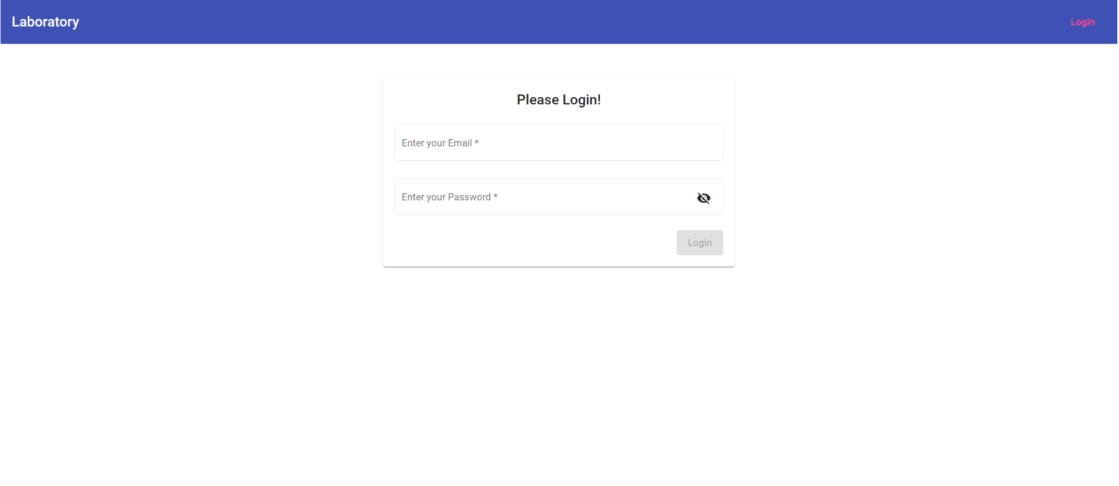

1. Register User

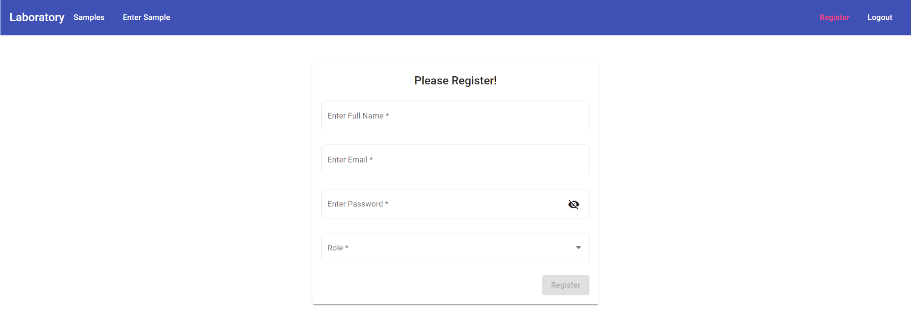

1. Admin home screen

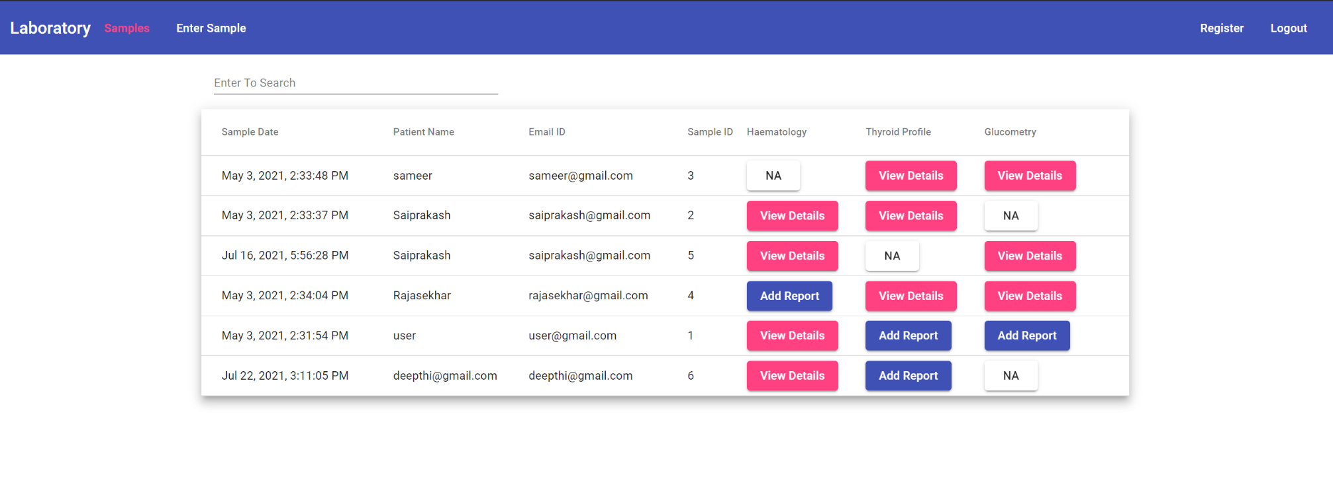

1. Enter Test Sample

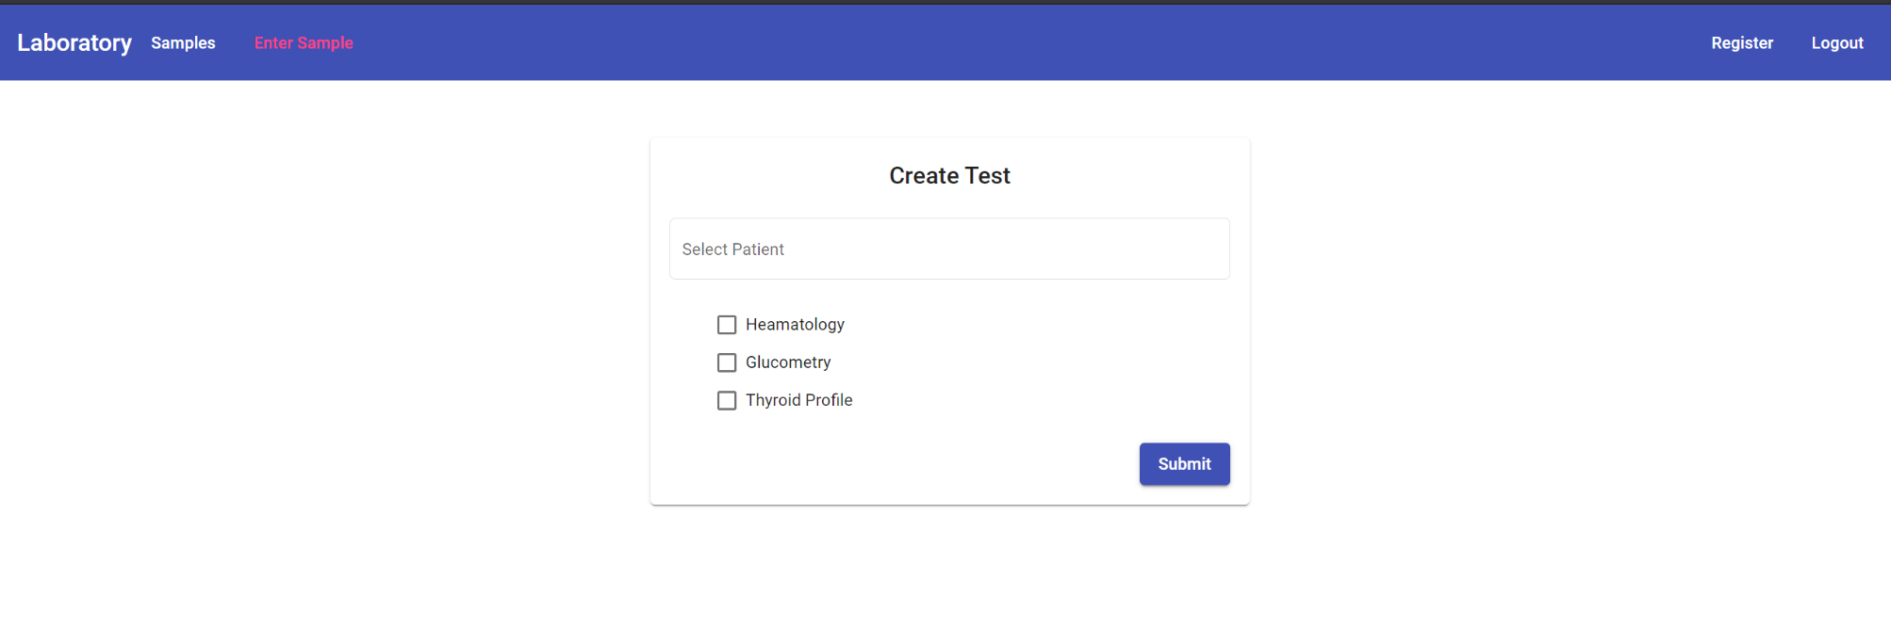

1. Enter Report 1

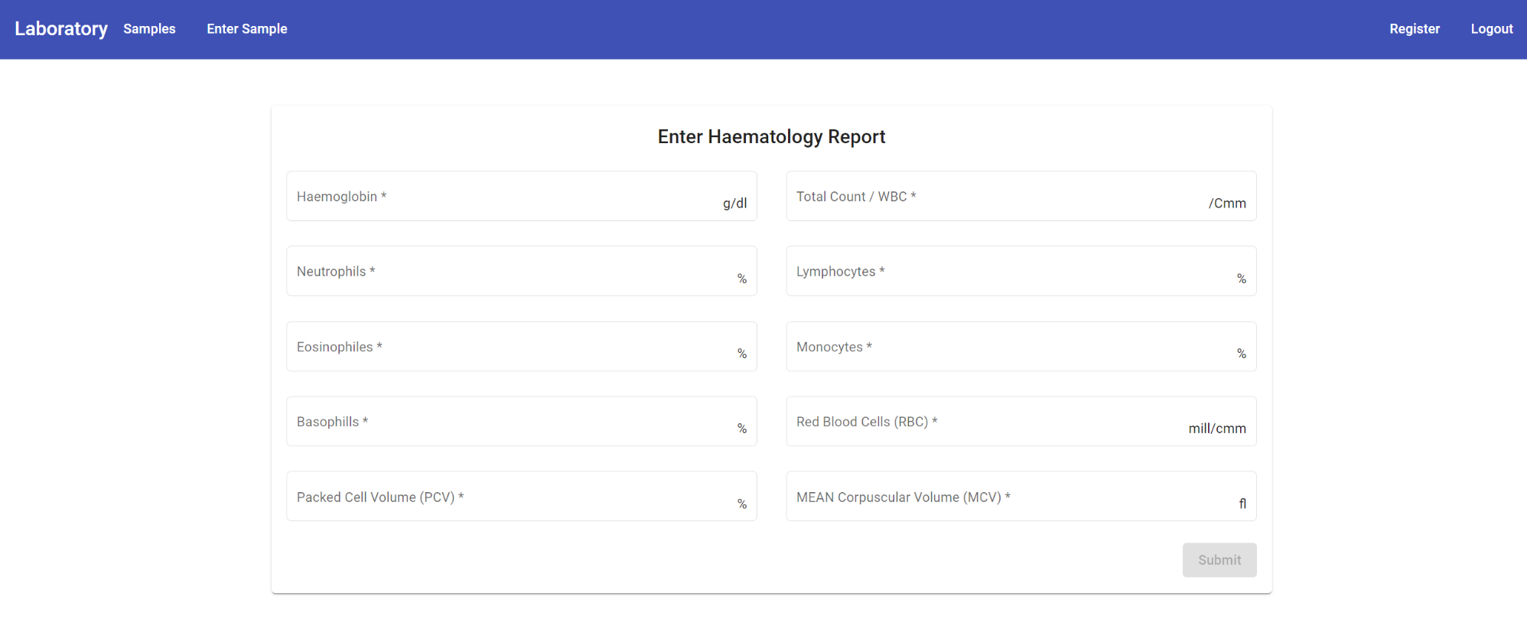

1. Enter Report 2

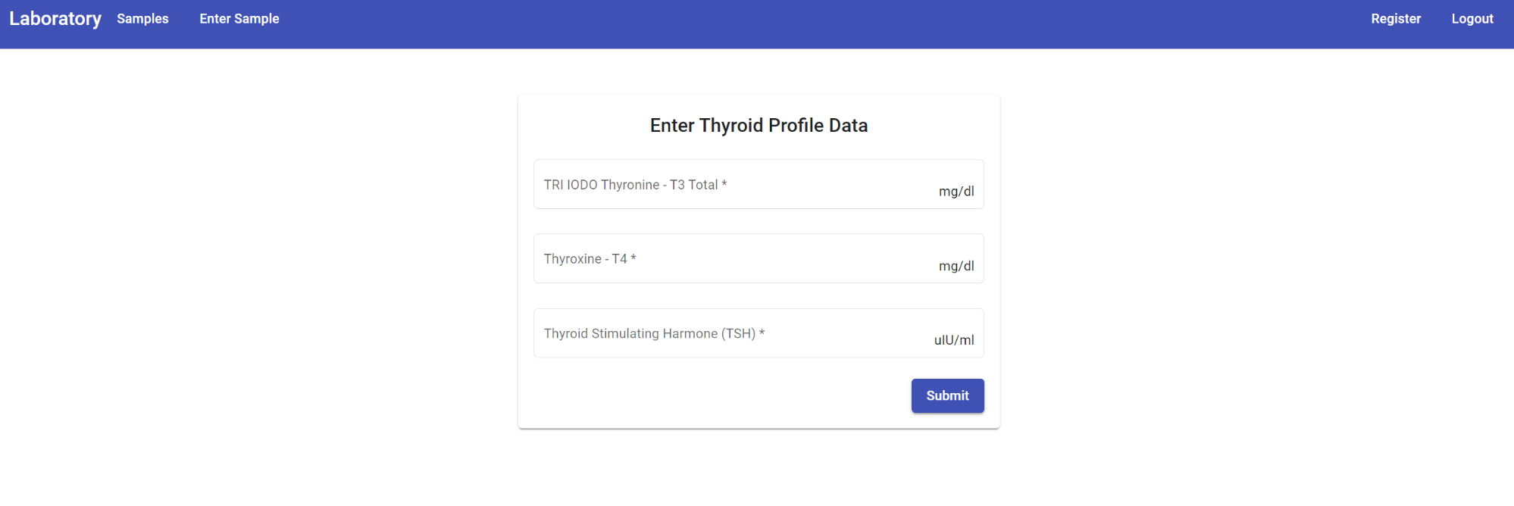

1. Enter Report 3

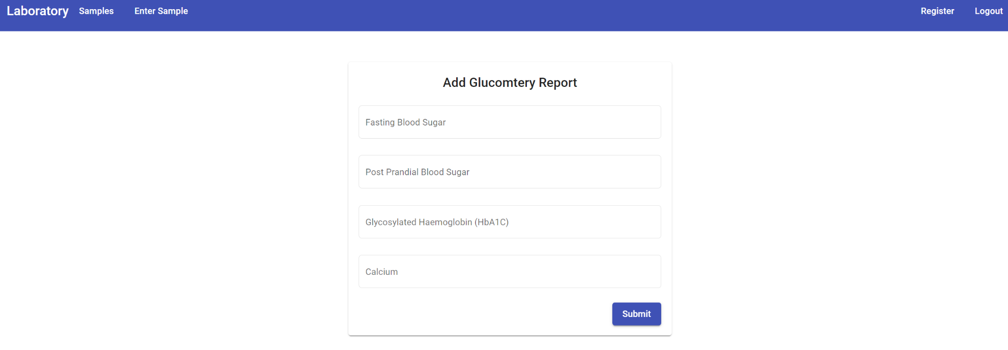

1. Add Report 1

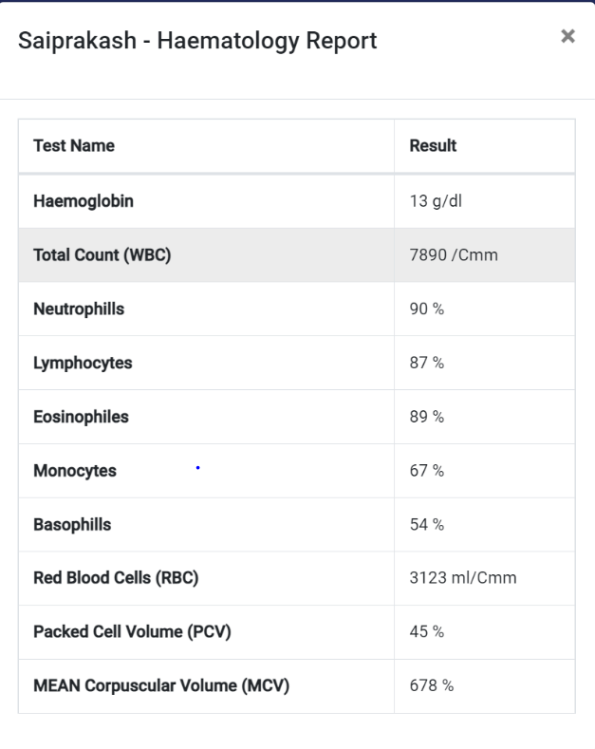

1. Add Report 2

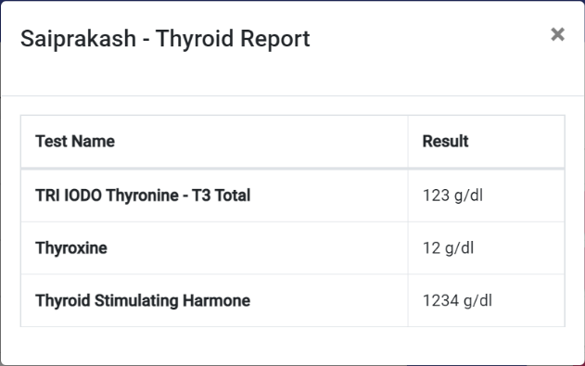

1. Add report 3

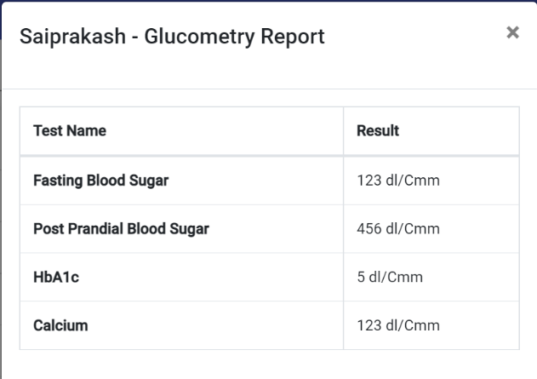

**Screenshots for Reference(User)**

1. Home Screen

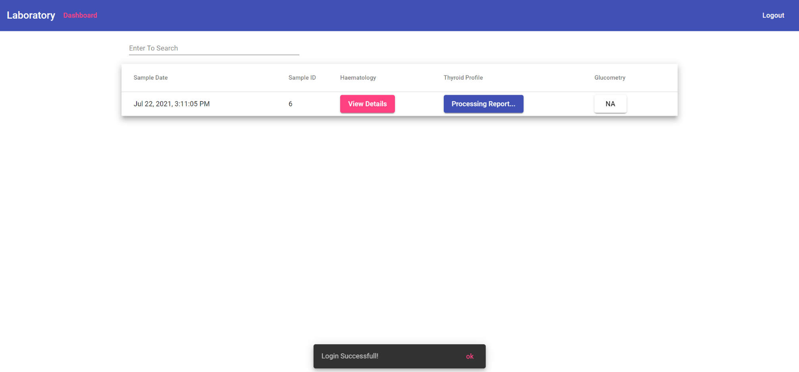

1. View Details

